**Peshawar:**

Bala Hissar Fort

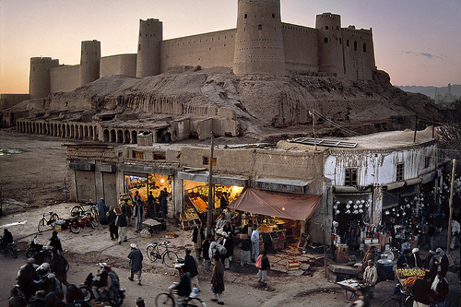

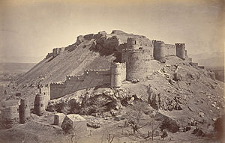

**Bala Hissar** also spelt **Bala Hisar**, is a historic fortress located in Peshawar, Khyber Pakhtunkhwa, Pakistan. The fort was used as a royal residence for the Durrani Empire, and was renovated during Sikh rule. The fort now serves as headquarters for Pakistan's Frontier Corps. The fort stands on a high mound in the northwestern corner of Peshawar City. Not long ago, the fort used to be conspicuously away from the old city of Peshawar, but now the construction of new buildings has covered space between the old city and the fort. However, the fort's position on a high mound gives a commanding and panoramic view of Peshawar and the entire Peshawar valley.